**Steps to connect C with Java through JNA**(Java Native Interface)

1. We need to install minGW (*Minimalist GNU for Windows)* which facilitates in compiling c/c++ program using GCC (GNU compiler collection) and creating .dll files etc...
2. Compile the .c code
3. Run **"C:\TDM-GCC-64\bin\gcc.exe" -m64 -c -I"C:\Program Files\Java\jdk1.7.0_65\include" -I"C:\Program Files\Java\jdk1.7.0_65\include\win32" cTest.c** in command prompt. This will generate .o file for the C program. This we have to pass to create DLL for our C program.
4. Run **g++ -shared -m64 -o ctest.dll cTest.o** which will create **.**DLL (dynamic linking library) for the C program, which we can access from any other compiler.
5. Place this .dll file in our java project and create interface by extending com.sun.jna.Library and put the methods that we want to use from C program

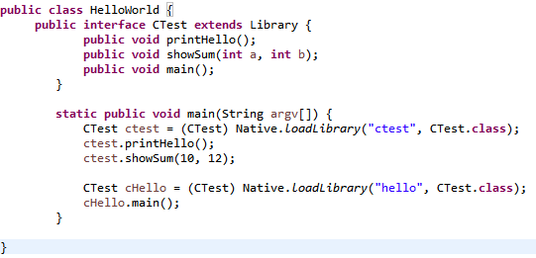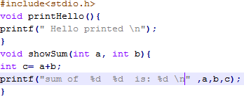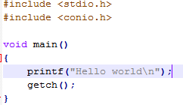

ctest.c

hello.c

